Step-1: Click on Manage Jenkins ---🡪Manage Nodes and Clouds

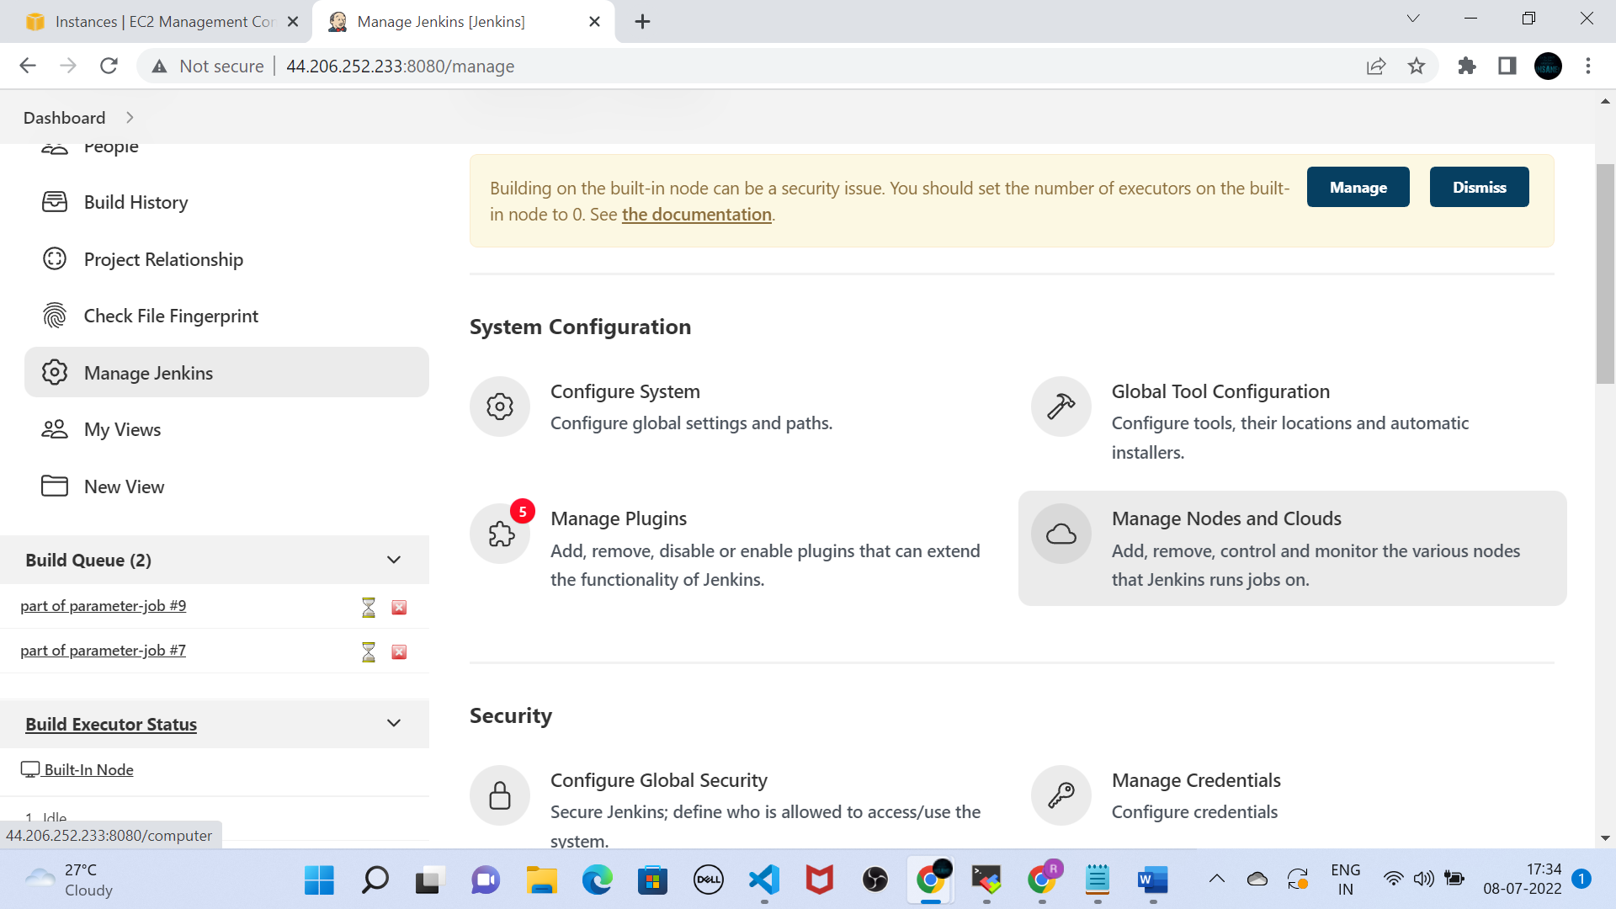

Step-2: Click on New Node

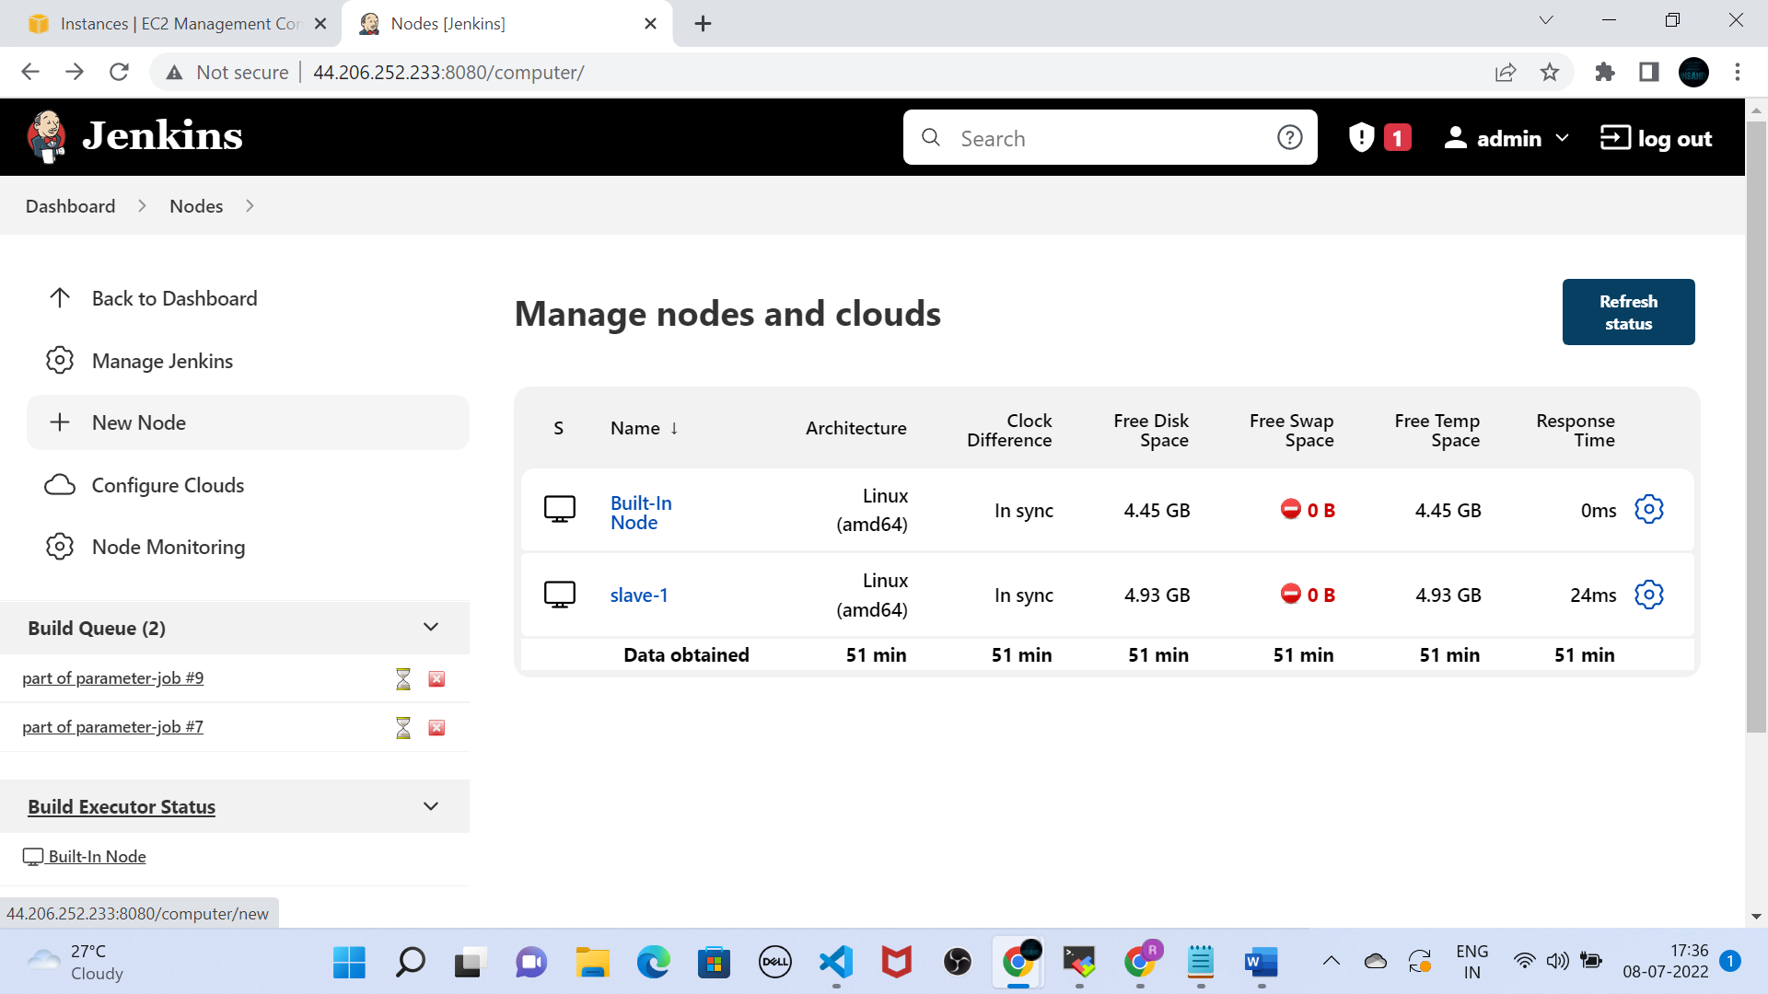

Step-3: Give Node name and Select type as Permanent Agent and then click on Create

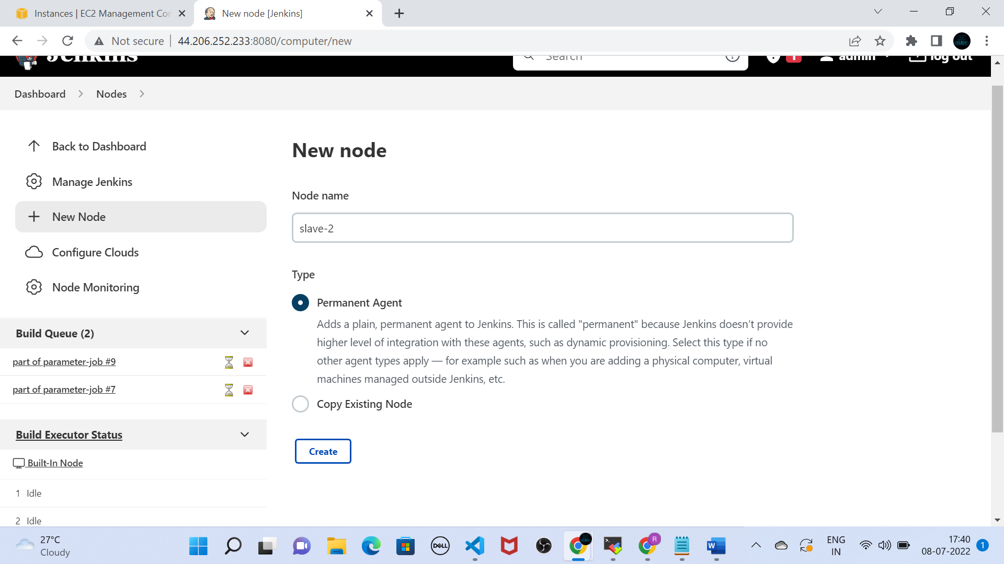

Step-4: Fill Name ,Remote root directory, labels section.

Under launch method(select launch agent via ssh) , under username provide public ip of ec2-machine, in credentials ( select SSH username with private key) and click on save

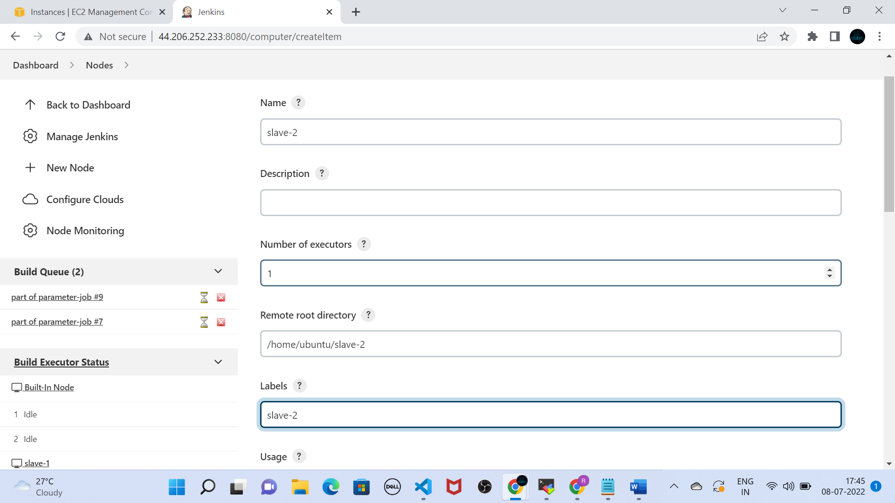

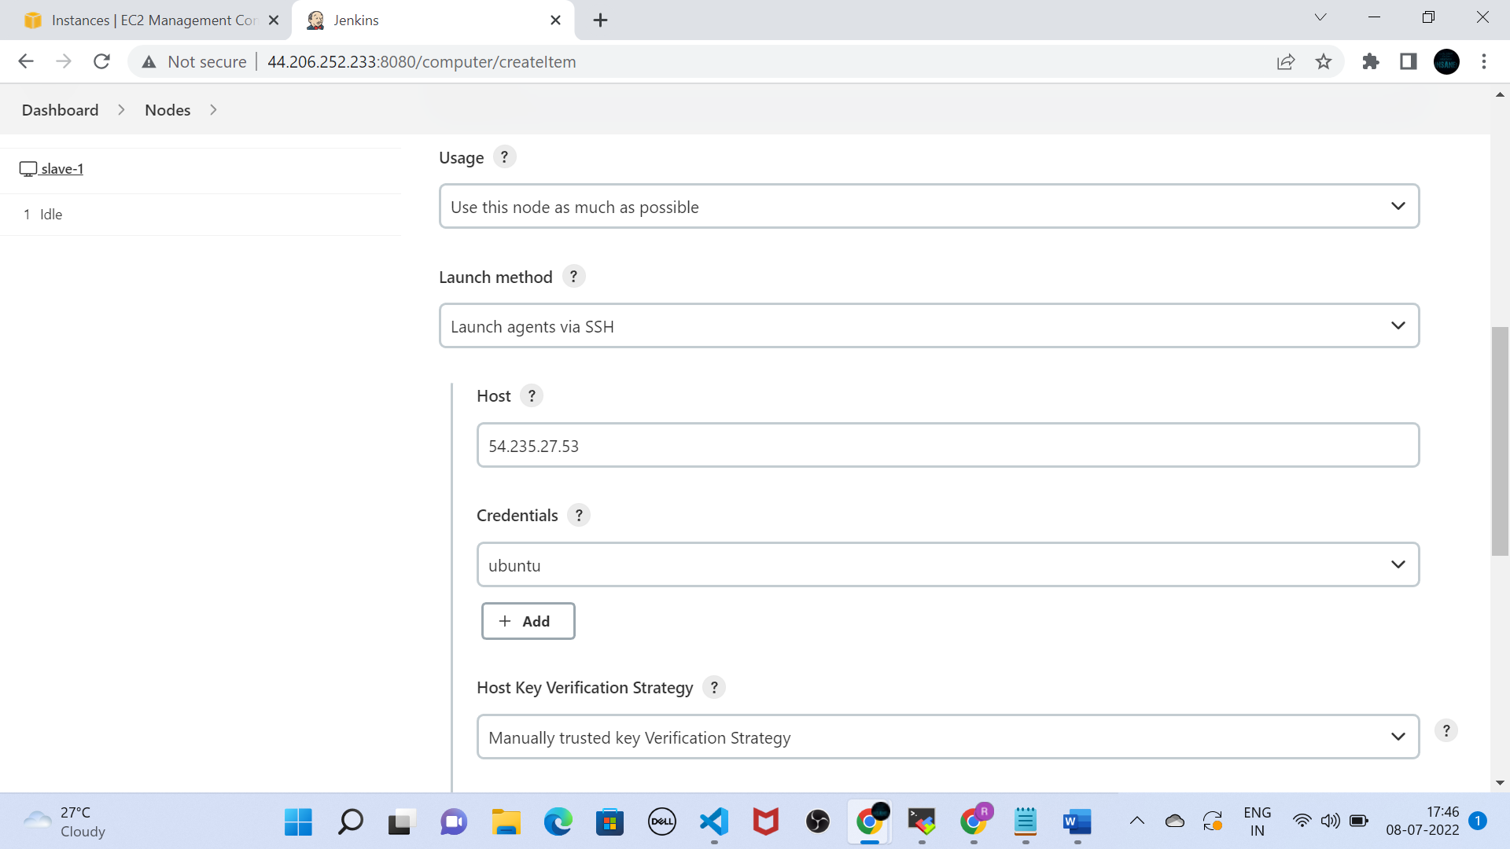

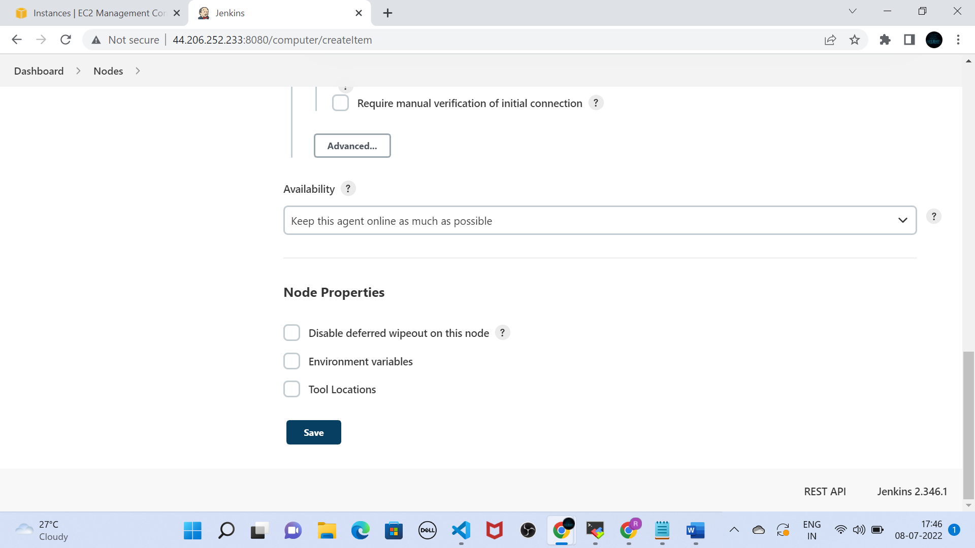

Step-5: check the slave-2 is in idle state

Configure Github-webhook with Jenkins

Step-1: Under **Source Code Management , select git**

If repo is in private , provide github credentials

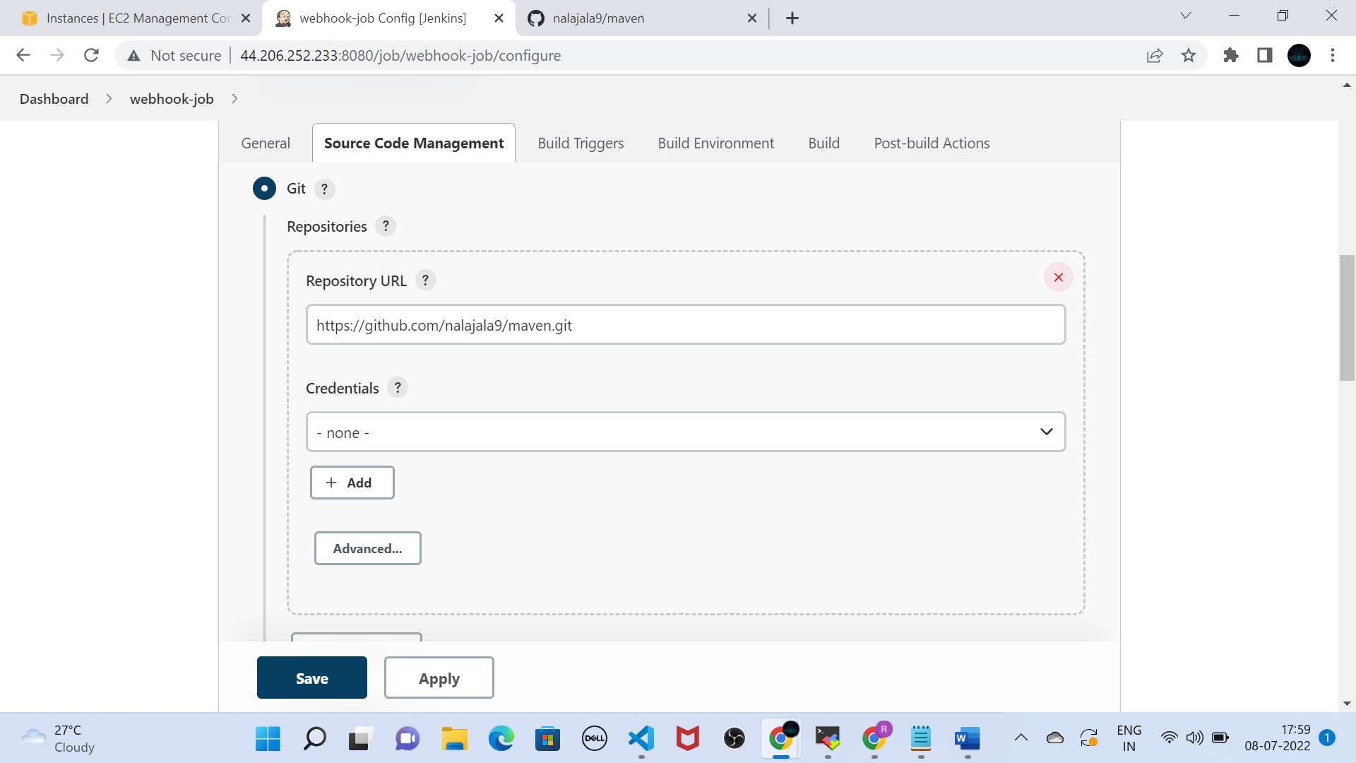

Step-2: In build triggers, select GitHub hook trigger for GITScm polling

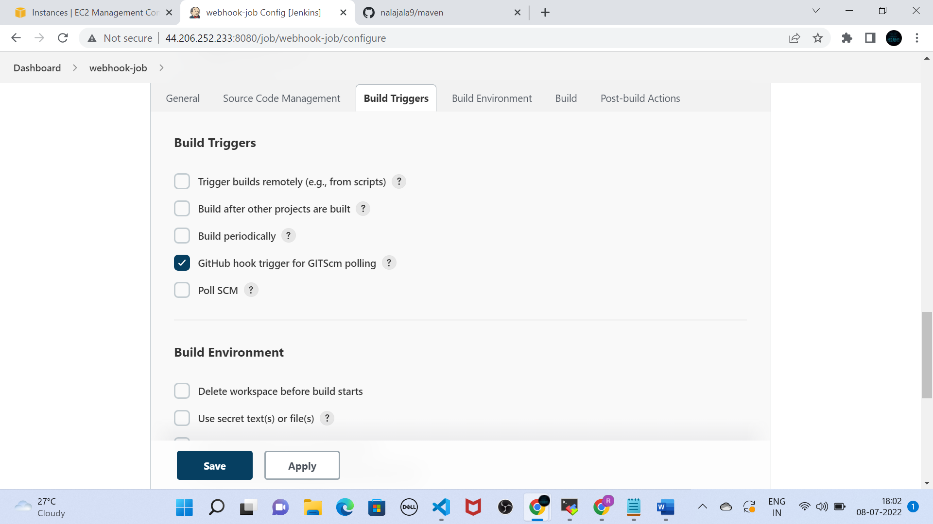

Step-3 : Click on apply and save.

Step-4: Go to github , click on settings-🡪Webhooks and paster the Jenkins url as shown in the screenshot

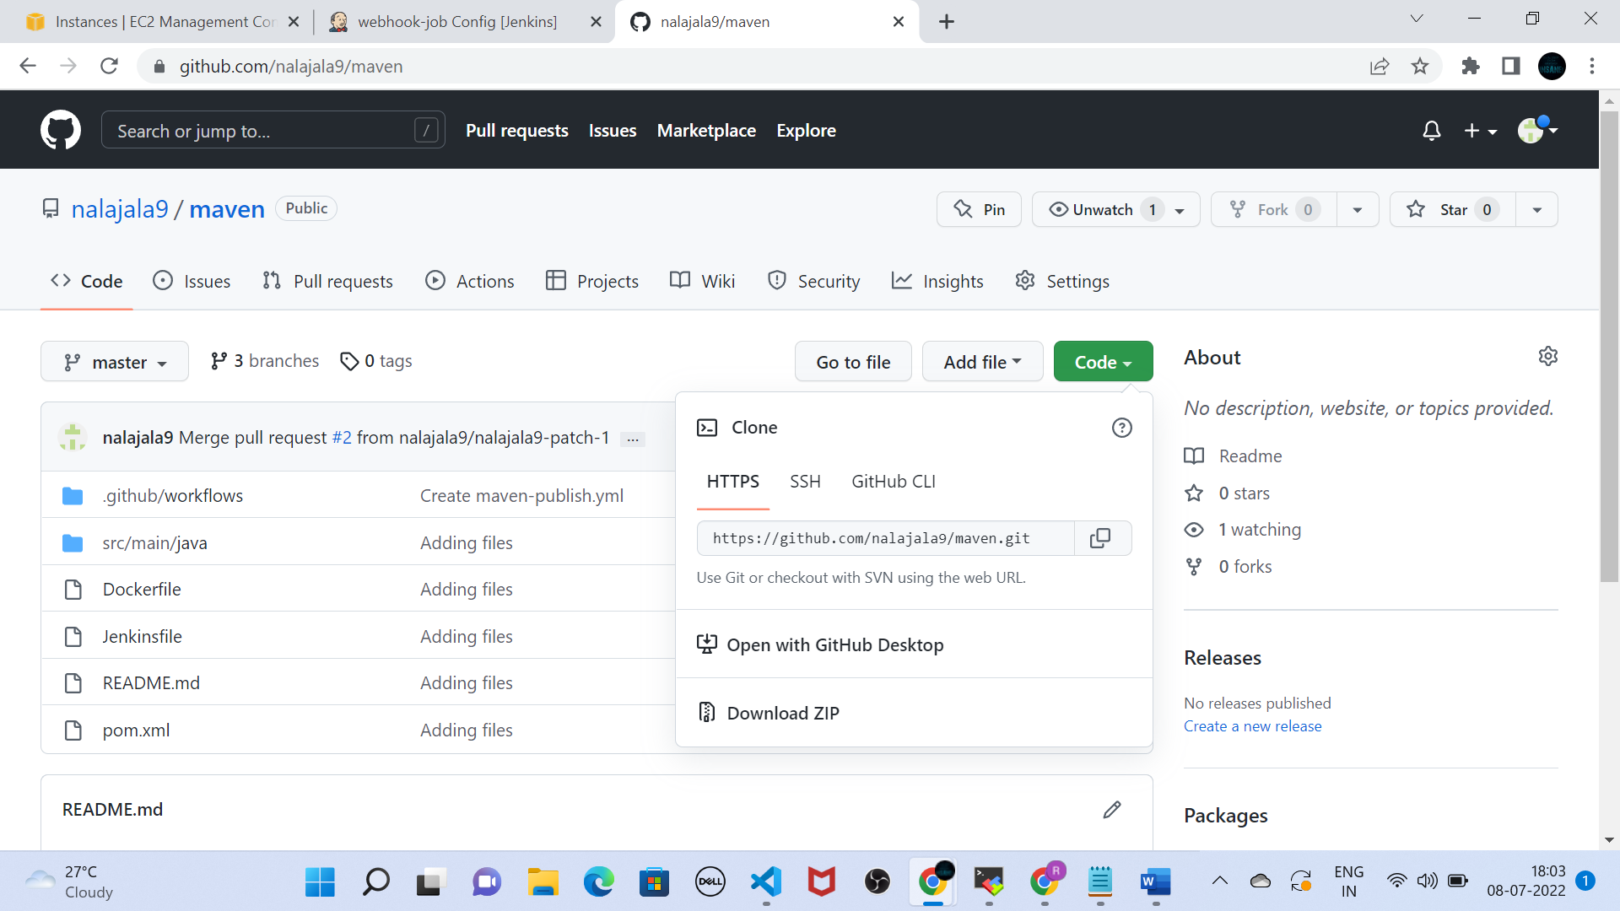

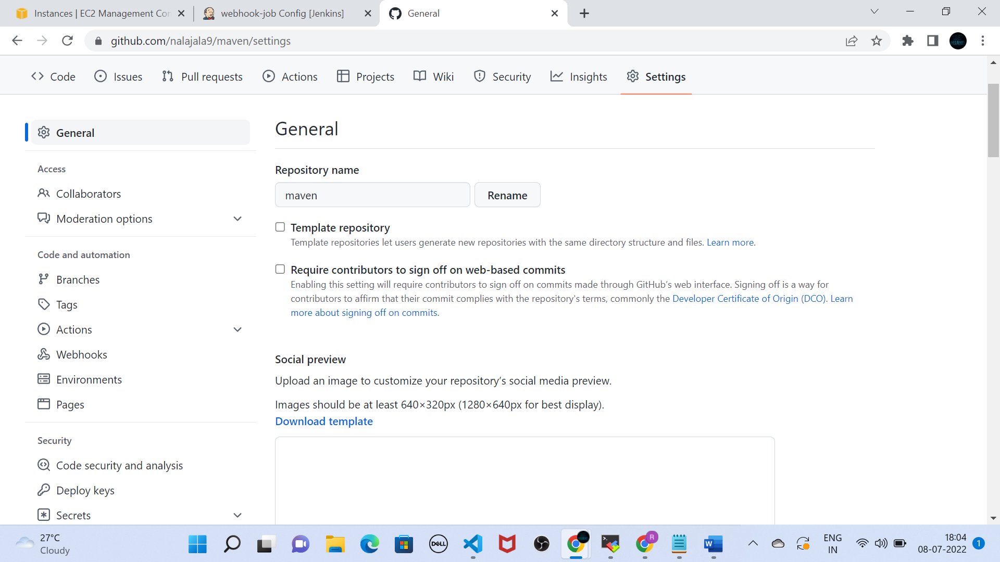

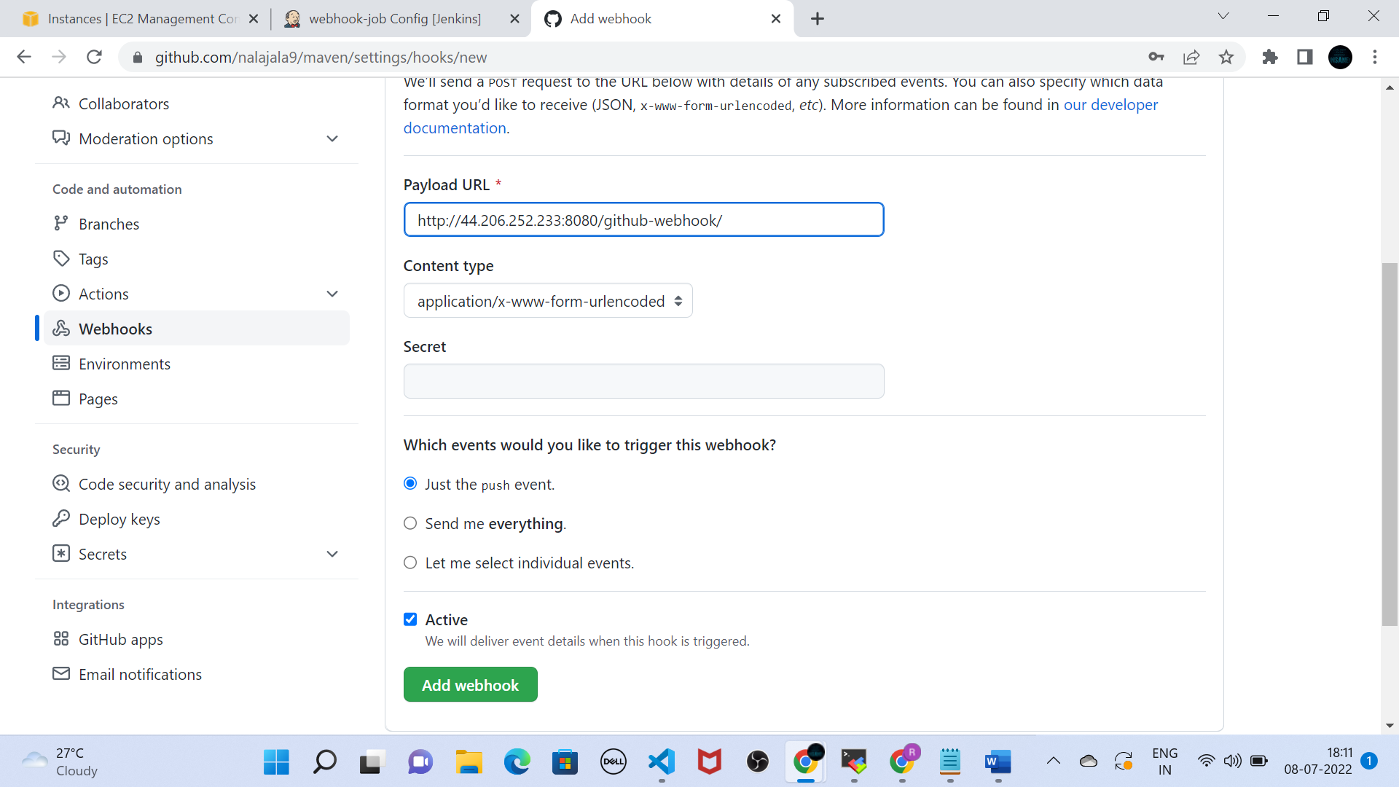

Step-5: Now commit changes to repo and check the builds are automatically triggered .